Software Requirements Specification
For
<CineMax>
Version 1.0 approved
Prepared by <Team CASPER>
Huali Luo (Team Leader)
Wong Wang
Meng Wang
Tejasi Joshi
Aafrin KhaN

<Last edited date: 27 Mar 2014>
Table of Contents
1. Introduction 1
1.1 Purpose 1
1.2 Document Conventions 2
1.3 Intended Audience and Reading Suggestions 3
1.4 Product Scope 4
1.5 References 5
2. Overall Description 6
2.1 Product Perspective 6
Use Case Diagram using UML (2010 Visio) 7
2.2 Product Functions 8
2.3 User Classes and Characteristics 9
2.4 Operating Environment 10
2.5 Design and Implementation Constraints 10
2.6 User Documentation 11
2.6.1 Watching CineMax 11
2.6.2 Under the Hood 11
2.7 Assumptions and Dependencies 14
3. External Interface Requirements 15
3.1 User Interfaces 15
3.2 Hardware Interfaces 16
3.3 Software Interface 17
3.4 Communications Interfaces 18
4. Functional Requirements (System Features) 19
4.1 Use case diagram: 19
4.2 Functional requirements presented by use cases: 20
5. Other Nonfunctional Requirements 26
5.1 Availability: 26
5.2 Reliability: 26
5.3 Security: 26
5.4 Usability: 26
5.5 Scalability: 27
5.6 Maintainability: 27
5.7 Business rules: 27
6. Other Requirements 28
6.1 Defect fixing 28
6.2 Changes to the software's execution context: 28
7. Appendix: 29
7.1 Appendix A: Glossary 29
7.2 Appendix B: Analysis Models 29
7.2.1 Data flow Diagrams 30
7.2.2 BNF Description of 1 Data Flow 32

Revision History
Name | Date | Reason For Changes | Version
Huali Luo | 3/27/2014 | Format update | Version 1.0

Introduction

Purpose
The purpose of this Software Requirements Specification is to describe the design, requirements, and features of the “Cinemax” software, version 1.0.

Considering multi-user expectations for online entertainments, we group intend to establishing a web-based application-“CineMax” -online movie rental systems including numerical hit movies, TV series with wider accessibility and advanced functions, by taking advantages of developments in information technologies like could computing.

Document Conventions

Term | Definition
Wi-fi | Wireless Fidelity
iOS | An operating system that all Apple mobile devices run on.
TV | Television
GUI | Graphic User Interface
DVD/CD | Optical storage device
HD | High Definition Video, has higher resolution than Standard Definition
XBOX/PS3 | Video Gaming console

Intended Audience and Reading Suggestions
This Software Requirements Specification is primarily intended for the following intended audience:

Developers:
Developer is a person concerned with facets of the software development process. Their work includes researching, designing, implementing, and testing software. A software developer may take part in design, computer programming, or software project management. They may contribute to the overview of the project on the application level rather than component-level or individual programming tasks.

Project Managers:
A project manager is the person responsible for accomplishing the stated project objectives. Key project management responsibilities include creating clear and attainable project objectives, building the project requirements, and managing the constraints of the project management triangle, which are cost, time, scope, and quality in the software development process.

Marketing Staff:
A person whose duties include the identification of the goods and services desired by our customers, as well as the marketing of movies and advertisement services on behalf of a CineMax.

Testers:
Tester is a person in charge of investigating to provide stakeholders with information about the quality of the software to allow the business to appreciate and understand the risks of software implementation.

Documentation writers:
People who are in charge of technical writing and producing technical documentation such as system manual for CineMax.

Users:
Users are our regular and premium customers who use our website to order a movie DVD/BlueRay, download a movie, and streamline a movie.

Reading suggestions:
This document contains information about the software requirements specifications for CineMax. To get a comprehensive idea of this requirement specification, the reader is encouraged refer to the product perspective and product functions sections of the document.

Product Scope
The web-based Cinemax applications is to offer customers a convenient way to enjoy better online video services with wider accessibility, multiple services (purchase/download/rent) and larger variety genre of movies utilizing advanced information technologies.
Readers can refer to the data flow diagram level 0 for the overview of systems.

DFD Level 0 and Level 1

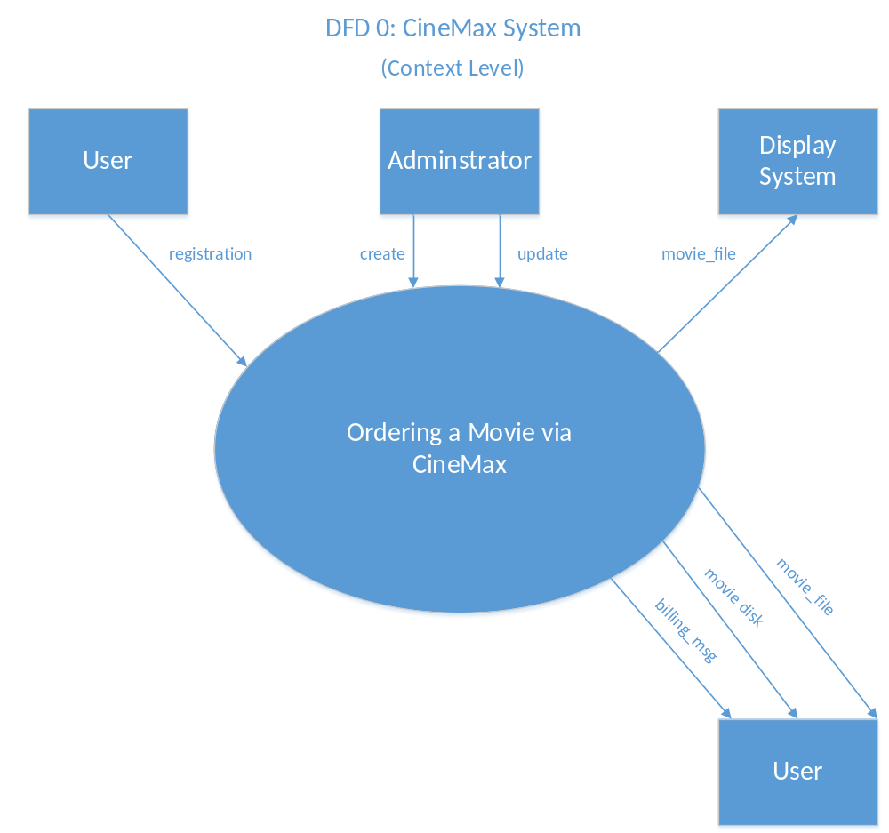

References
Websites:

http://www.amazon.com/movies-tv-dvd-bluray/b?ie=UTF8&node=2625373011

http://www.apple.com/itunes/charts/movie-rentals/

https://www.netflix.com/Default?locale=en-US

https://play.google.com/store/movies

Books:

“Software Engineering," Ian Sommerville, Addison-Wesley, England, 9th Edition, 2011.

Overall Description

Product Perspective
CineMax is a new, innovative product that will provide our users with online video rental systems that includes numerous hit movies and TV series.

As the internet becomes the infrastructure for E-commerce business, people tend to shop online instead of in-person. With the development of information technology, this priority can offer business lower price and robust competitiveness, compared to offline movie rental stores.

Except for Walmart or BestBuy online movie rental business which is due to their offline retailing background, other main online movie rental business are focusing on developing platform and high quality videos , like Netflix and Amazon instant video rentals, etc. None of them could dominate the movie rental market now.

CineMax will provide our users with wider accessibility and advanced functions by taking advantages of the developments in information technologies like cloud computing. It affords a unified environment that delivers powerful reporting features and highly effective advertising to the average consumer who is ultimately the end user of our application.

Readers can refer to the use case diagram to know components in the systems and their connections by implementing systems’ features.

Use Case Diagram using UML (2010 Visio)

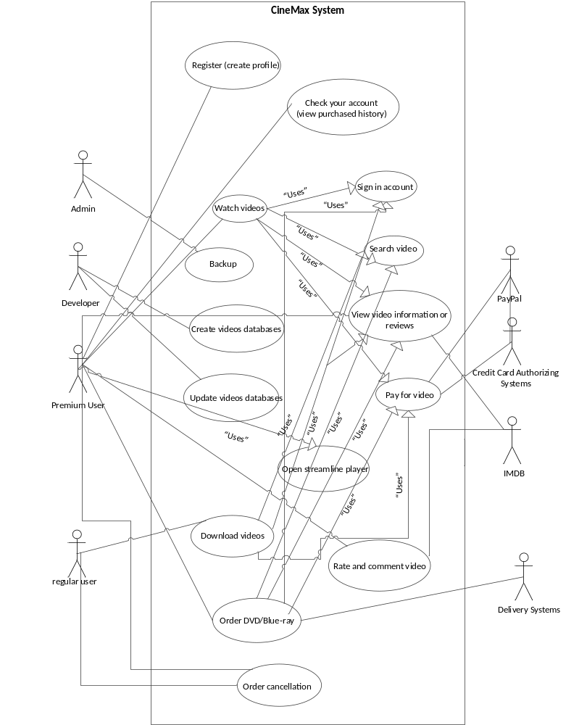

Product Functions
The following is a brief outline and description of the main functions of CineMax.

- User Registration: The system enables the user to register with the application on our website using a unique ID and password by providing information such as name, phone number, billing address, email address, credit card number, and email address etc. It also provides the user with our company’s privacy and security agreement.

- Choose resources (products): There are multiple recommendation systems in our home page with links to specialized movie recommendation websites such as IMDB.

- Pay for video services: Log into your account when ordering for security; Identify your account situation: if monthly subscription services, adding into subscription list; if no monthly subscription services, just purchase/download (“new released” should only be owned this way.) with different price and service.

- Watch videos: Purchase/download (range from $4.99 to $19.99 according to products situation); rent ($8.99 monthly subscription).

- Reporting & Analytics: The web-based application provides an interface where each user can view a history of their purchases.

- Cloud Computing: The system takes into consideration every transaction carried out by each user. This means that customer information is stored in the cloud and accessible to the system and the user from anywhere and at any time.

- Feedbacks and rating systems: Rating movies from score from 1 star to 5 stars; add customer’s own comment; can jump to IMDB for more reviews; be able to share with friends by Facebook social networks.

- Customer services management: Supportive information in technical aspect; return policy considering products quality problem.

- Classification of ads: The application can classify ads (according to deals, coupons, customer loyalty programs, new additions to the movie database etc.) and enable the customer to select what class of adverts he or she wants to receive.

- Background Monitoring of User Activity: The application will run silently in the background of our web-based application, having access to features such as the browser cookies, history etc. This will enable us to understand what the user is interested in and use the information obtained to make more precise classifications and provide more tailored adverts.

User Classes and Characteristics
Visitors:

Visitors are brand new customers who have not registered for the CineMax application. They are very important and the administration aims to lure such visitors to become our customers. Special features of the movie application and the ratings and review from current customer are displayed to attract the visitors.
Visitors can:
- Read CineMax’s movie review and ratings
- Read FAQs
- Register and create an account

Members:

Members are users that have registered and created an account. There are two types of members of this application – Regular Members seeking to purchase a movie and Premium Members looking for instant streaming movie online.
Members can:
- Order a movie DVD or BlueRay (Regular Members or Premium Members)
- Download a movie (Regular Members or Premium Members)
- Streamline a movie (Premium Members)
- Post reviews (Regular Members or Premium Members)
- Rate application (Regular Members or Premium Members)

Administrator:

The administrator of CineMax is responsible for the maintenance of the application and the movie and customer databases.
The administrators must:
- Maintain and update application.
- Update Member profiles.
- Create and Update movie database.
- Solve technical problems if any.

Operating Environment
The environment in which the software will operate are Windows 7/8, IOS, and OSX.

1) Software: web server of Windows network frame, ASP.NET and C#
2) Customer environment: Windows 7/8, IOS, OSX
3) Databases: SQL Server DBs
4) Languages: English

Media are generally compressed for both storage and streaming. Increasing consumer demand for streaming of high definition (HD) content has led the industry to develop a number of technologies such as WirelessHD or ITU-T G.hn, which are optimized for streaming HD content without forcing the user to install new networking cables.

Live streams are generally provided by a means called "true streaming". True streaming sends the information straight to the computer or device without saving the file to a hard disk. Progressive streaming saves the file to a hard disk and then is played from that location. On-demand streams are often saved to hard disks and servers for extended amounts of time; while the live streams are only available at one time only (e.g., during the football game).

Design and Implementation Constraints
- Information infrastructure establishment: access to Cloud computing.
- Higher requirements for developers’ skills for simpler but good user experience design.
- The competitive situation in the online movie rental services markets.
- The copyrights issues when obtaining larger videos databases.

User Documentation
Online Help:
How does CineMax work?

How does CineMax billing work?

Watching CineMax
What can I use to stream CineMax to my TV?
How do I watch CineMax on my computer?
What’s the selection like?
Can I stream CineMax in HD?
Where is CineMax available?

Under the Hood
How fast does my Internet need to be?
How many devices can I use CineMax on at the same time?
How does the CineMax App work?

User Manual:

The Complete Guide to CineMax:

We've established a special section just for featuring our best and most popular CineMax-related content. You can learn more about the various ways you can use CineMax on other devices like game consoles and smartphones. There are also quite a few tricks and shortcuts you can use to get more out of the service.

How CineMax Works:

If you are new to this service and want to know what you can expect as a subscriber, then it never hurts to learn more about what you're buying into. Discover what devices support streaming video, and also find out about your options for DVD or Blu-ray, since CineMax can handle both. Is it worth ditching your cable or satellite service for a subscription to CineMax? Some people think so.

Tips and Tricks for Using CineMax:

You should take the time to explore the CineMax menus and see what kind of options is available. Going through the vast selection of movies and rating them will help the system to find you better recommendations. There are also some technical issues you may encounter that can hinder your experience. Learning your way around the system is the best way to get your money's worth from this online streaming service.

The Best CineMax Streaming Devices:

There are many different ways in which you can watch streaming content from CineMax. It used to be only for your computer, but has since expanded to video game consoles and handheld devices. The problem is that performance is not the same across all mediums, so you may want to know which ones work best and what to expect from other delivery methods depending on the hardware involved.

How to Watch Streaming Movies on Your TV or HDTV:

So you want to watch streaming movies on your TV, but aren't sure how to go about it? CineMax is simple to use, but there is a bit of setup involved and this can be confusing to those without technical skills. Learn more about how to setup your TV, video game console, and other devices for online streaming so you can watch your favorite movies and TV shows.

Keyboard Shortcuts for Online Streaming Video:

If you are watching CineMax on your computer, you may wish that you had a remote control like you would on a TV. Knowing the right keyboard shortcuts will fix this problem. You can do simple stuff like pause the video or make it full screen, but did you know there are options for showing video and audio performance, like the frame rate? You can control the volume and everything else with the keyboard, and that's great for users with wireless input devices.

CineMax for PlayStation 3 Owners:

If you have a Sony PS3 video game system and subscribe to CineMax, you can download a program that lets you stream video directly from the game console. This allows you to use the same audio and video settings as used for your games, and therefore you can gain access to a lot of HD content like movies and TV shows. Best of all, it's a free service if you already subscribe.

Recommended HDTV Settings for PS3:

PlayStation 3 owners with HDTV's should make sure they are using the system to its utmost capacity by tweaking the audio and video settings. This will not only make games look their best, but will also help when watching movies on DVD or Blu-ray, and when streaming video via CineMax. You'd be surprised how much difference a few little changes can make, and it can all be done from the main menu on the PS3.

What You Should Know about CineMax and the Nintendo Wii:

Although Nintendo Wii owners have the option to use CineMax for streaming via the game console, it's really not the best way to go about it. The main reason is that the Wii only supports up to 480p, so you will be missing out on all the true HD content available online. Given the limited graphical capabilities of the Nintendo system, you should consider other options like the Roku if you want to stream movies to your HDTV.

How to Get Better Graphics with the Nintendo Wii:

Although the Wii isn't the best option for watching CineMax, this may be the only option for a lot of people. If this is the case, then there are at least some changes you can make that will improve the picture quality of the Wii's video output. This will make some games look better, and will also improve how your movies look and sound. All you have to do is know where to look in the system menu and what options work best.

What to Expect with CineMax for Android:

Some Android phone users can enjoy CineMax live streaming on their phone or tablet device, but only if their model is supported. The biggest drawback to this, as you might expect, has to do with bandwidth limitations. Sometimes cell phone service is too spotty to get a decent video stream for a full length movie. It may be great for watching short YouTube videos, but isn't so reliable for longer videos. Even so, the app is free to download so it's worth trying.

CineMax for iPhone or iPod Touch:

If you have an Apple portable device like the iPhone or iPod Touch, you will be pleasantly surprised by how well CineMax works on them. It's even better when you enable the Wi-Fi connection at home or anywhere wireless Internet service is available. The app is free to download from iTunes and definitely worth having. It's even better on an iPad with the larger screen.

CineMax and Windows Media Center:

Windows Media Center is a great multimedia feature found in some of the higher-end versions of the Windows operating system. It allows you to turn the PC into a full featured home entertainment center, so naturally you'd want CineMax to be a part of that system. Combine this with a large display and you won't even need a regular television any more.

How to Hide Your 'Recently Watched' History:

CineMax will keep a history of whatever movies you have watched, and this can sometimes be a problem when you share a home account with others, especially children. You may not want to see what cartoons they've been watching and you definitely don't want them to see what kind of stuff you and the wife have been watching after the kids went to bed. There is no simple way to completely clear your history, but there are some tricks you can use to hide some of the titles.

Assumptions and Dependencies
- Credit card verification systems and PayPal for successful payment authorization.
- Connection to IMDB for more movie information and reviews.
- Delivery systems to send products to customer.
- Software operations system such as IOS, OSX and Windows 7/8.
- Computer devises run by these operations systems.
- Updates on these systems will have strong impact in terms of application capability, Cellular network including Wi-Fi, 3G, 4G and GPS.
- Database for all activities recording.
- Internet/WIFI connectivity.

External Interface Requirements

User Interfaces
User enters into the website and log in with account and password by permit from customer database. User can search recourses via video database by title or name of cast as the key word to retrieve system. User could effectively use the navigation systems to find videos when having no idea to watch an identical movie. The main page interface will also offer commercial banners with promotional information. User has different choice for different video services with different price. After choosing movie and service, then user should be authorized by payment systems with the private financial information he enters. After watching video, user can easily post his own comments on the movie page. User can also share it with your other social network links like Facebook.

Layout description:
- homepage layout design:
- account in top right corner
- slogan “watch all you want”
- main site navigation in top
- 4/5 dynamic banners presenting promotions in the center
- important artifacts and contacts in the bottom
- advertisements show in the narrow left

- movie page layout design
- left block: main navigation systems by genre, released time, region
- Center block: recommendation panels: best seller, new released, top rated, you may like
- page layout: 20 items per page

- navigation design

- rate and comment systems
- score videos from 1 star to 5 stars
- add own comments easily
- link to IMDB

- supporting artifacts/statements
- help instruction
- feedback channel
- customer service contacts
- legal and licensing issues

- graphic design
- base color and context design
- promotional static banners
- dynamic banners
- icons design
- movie information presentation
- advertisements presentation

Hardware Interfaces
- Ethernet, TCP/IP Protocol
- Simulated Virtual Interface

This modality has multiple applications:
- Create programs to verify their operation without having concluded the hardware.
- Verify the programs of other systems.
- As method of learning PLC languages.
- Approach to industrial automation.
- If this interface is selected, when the PLC is started the window will appear with the available inputs/outputs if it is selected from the EasyPLC notify icon. Pressing on inputs buttons it is possible to force their state to ON/OFF as well as to visualize the state of the outputs.

Software Interface
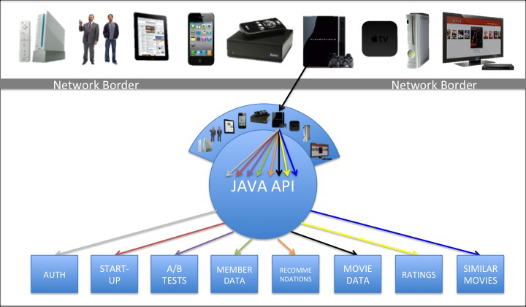

Communications Interfaces
- Web server, on which we will host our site.
- Internet/WIFI connectivity, to get connected with the site.

Functional Requirements (System Features)

Use case diagram:

Functional requirements presented by use cases:
Use case 1: Register:

Characteristic information:
Goal in context: The user creates an account so that he/she begins to use the application to rent or purchase a movie or TV series.

Scope: CineMax system
Level: Primary task
Primary actor: User (purchaser or renter)
Channel to primary actor: Movie library

Preconditions: Working internet access
Success end condition: User has successfully created an account in the CineMax system
Failed end condition: User is unable to register for CineMax account

Sunny Day Scenario:
System displays CineMax website homepage
User click register for an account
System direct user to fill profile with inputs: account name, password, first name, last name, Gender, E-mail address, credit card information, and security question/answer.
User inputs the required information values
User submits the information
System authenticates the given information, verifies uniqueness of email address and account name and credit information and stores the information in the new member account
System automatically sends a welcome email to user
User browses what they are interested in

Extensions:
3a. if user has left some required field blank:
System will direct the user to enter all required fields
3b. if system finds duplicate account name:
System will direct the user to change another account name
6a. System finds duplicate email address:
System will direct the user to change another address
6b. Server fails during the registration:
System will direct the user to try again

Variations: No variations
Related information:
Priority: High
Performance target: 1 min
Frequency: 20000 times
Schedule:
Due data: release 1

Use case 2: Check member’s account:

Characteristic information:
Goal in context: The member successfully views his or her purchased history.

Scope: CineMax system
Level: Primary task
Primary actor: Member
Channel to primary actor: Movie library

Preconditions: User is registered, working internet access
Success end condition: The member is authenticated and has successfully logged into the CineMax system. (Member check their profile and view purchased history)
Failed end condition: Member is unable to log in the CineMax system

Sunny Day Scenario:
1. System displays CineMax application homepage
2. Member inputs his or her account name, password, and verification code and click sign in.
3. System verifies and validates required fields (Account name and Password)
4. System shows that member is successfully logged in.
5. System automatically checks your account and identified the type of account (Premium or
Regular)
6. Member check his or her profile and view purchased history

Extensions:
2. If user has left some required field blank:
System will direct the user to enter all required fields
3a. Member enters invalid information:
System will notify member that the provided ID or password is invalid.
3b. Server fails during the registration:
System will direct the user to try again

Variations: No variation

Related information:
Priority: High
Frequency: 20000times
Schedule:
Due data: release 1

Use case 3: Member sign in

Characteristic information:
Goal in context: The member signs in so that he or she rents or purchases a movie or TV series. The system will check member’s account type (Premium or Regular).

Scope: CineMax system
Level: Primary task
Primary actor: Member (Premium member, Regular member)
Channel to primary actor: Movie library

Preconditions: User is registered, working internet access
Success end condition: The member is authenticated and has successfully logged into the CineMax system. (Member check their profile) System checked and identified type of account.
Failed end condition: Member is unable to log in the CineMax system

Sunny Day Scenario:
System displays CineMax application homepage
Member inputs his account name, password, and verification code and click sign in.
System verifies and validates required fields (Account name and Password)
System shows the prompt to prove that member is successfully logged in.
System automatically checks your account and identified the type of your account (Premium or
Regular)
Member checks their profile.

Extensions:
2. If user has left some required field blank:
System will direct the user to enter all required fields
3a. Member enters invalid information:
System will notify member that the provided ID or password is invalid.
3b. Server fails during the registration:
System will direct the user to try again

Variations: No variations

Related information:
Priority: High
Frequency: 20000 times
Schedule:
Due data: release 1

Use case 4: Search videos

Characteristic information:
Goal in context: The member can search his or her interesting videos

Scope: CineMax system
Level: Primary task
Primary actor: Members
Channel to primary actor: Movie library

Preconditions: working internet access.
Success end condition: The member successfully searched his or her interesting videos
Failed end condition: The member is unable to search videos

Use case 5: View video information or reviews
Characteristic information:
Goal in context: This is important for users. Users can choose the movies according to these information and reviews. This is also important for administrator, depending on the reviews, administrator can figure out what kinds of movie most members would like to see, so that administrator can find and put more popular movies in the movie library.

Scope: CineMax system
Level: primary task
Primary actor: Members, Administrator
Supporting actor: Movie library, CineMax system

Preconditions: User is registered, working internet access, member signed in, member successfully search for video
Success end condition: The member successfully view his or her video information or reviews
Failed end condition: The member is unable to view his or her video information or reviews

Use case 6: Pay for video

Characteristic information:
Goal in context: to pay the purchasing expense.

Scope: CineMax system, Movie Library, Credit card authorizing systems
Level: Primary task
Primary actor: Members
Supporting actor: CineMax system, Movie Library, Credit card authorizing systems.

Preconditions: User is registered, working internet access, member signed in, member successfully search for video
Success end condition: The member successfully pays for his or her purchase
Failed end condition: The member is unable to pay for his or her purchase

Use case 7: Watch video (for rent)

Characteristic information:
Goal in context: the member has successfully rent a movie online.

Scope: CineMax system
Level: Primary task
Primary actor: Members
Channel to primary actor: Movie library

Preconditions: user is registered for premium account, working internet access, member signed in, member successfully search for video, member successfully pay for his or her purchase

Success end condition: The member successfully watched movie on our website.
Failed end condition: Member failed to watch movie.

Use case 8: Order DVD/Blue-ray

Characteristic information:
Goal in context: The member has successfully purchased a movie and received a DVD/Blue-ray.

Scope: CineMax system
Level: Primary task
Primary actor: Members
Supporting actor: Movie library, CineMax system, Delivery system.

Preconditions: user is registered for premium account, working internet access, member signed in, member successfully search for video, member successfully pay for his or her purchase

Success end condition: The member received DVD/Blue-ray.
Failed end condition: Member does not receive DVD/Blue-ray.

Use case 9: Download movie:

Characteristic information:
Goal in context: The member has successfully purchased and downloaded a movie online.

Scope: CineMax system
Level: Primary task
Primary actor: Members
Channel to primary actor: Movie library

Preconditions: user is registered for premium account, working internet access, member signed in, member successfully search for video, member successfully pay for his or her purchase

Success end condition: The member successfully downloaded the movie.
Failed end condition: Member is not accessible to the movie’s download link or member was accessible to the movie’s download link, but failed to download movie under a good network.

Use case 10: Order cancellation

Characteristic information:
Goal in context: Member can cancel their order before they received their movie.

Scope: CineMax system
Level: Primary task
Primary actor: Members
Supporting actor: Movie library, CineMax system

Preconditions: user is registered for premium account, working internet access, member signed in, member successfully search for video, member successfully pay for his or her purchase
Success end condition: The member cancelled his or her order successfully
Failed end condition: Member failed to cancel his or her order

Use case 11: Back up

Characteristic information:
Goal in context: The administrator back up the whole system including CineMax systems and movies library in other to prevent the collapse of the systems.

Scope: CineMax system, Movie Library
Level: Primary task
Primary actor: Administrator
Supporting actor: Movie library, CineMax system

Preconditions: working internet access
Success end condition: The administrator back up the whole system successfully
Failed end condition: The administrator failed to back up the whole system

User case 12: create videos database

Characteristic information:
Goal in context: The administrator has to create videos databases to store large numbers of movie and link the database to CineMax system.

Scope: CineMax system, Movie Library
Level: Primary task
Primary actor: Administrator
Supporting actor: Movie library, CineMax system

Preconditions: working internet access
Success end condition: The administrator creates videos database successfully
Failed end condition: The administrator failed to create videos database

Use case 13: Update videos and users databases

Characteristic information:
Goal in context: The administrator has to update videos databases and user profiles for better service.

Scope: CineMax system, Movie Library
Level: Primary task
Primary actor: Administrator
Supporting actor: Movie library, CineMax system

Preconditions: working internet access
Success end condition: The administrator updated videos and users database successfully
Failed end condition: The administrator failed to update videos and users database

Use case 14: Rate and comment video

Characteristic information:
Goal in context: Members rate their overall experience including search, price, film capacity, and movie by giving stars from 1 to 5 and feedbacks.

Scope: CineMax system
Level: Primary task
Primary actor: Members
Supporting actor: Movie library, CineMax system

Preconditions: user is registered for premium account, working internet access, member signed in, member successfully search for video, member successfully pay for his or her purchase
Success end condition: The member provided rating and feedbacks
Failed end condition: The member failed to provide rating and feedbacks

Other Nonfunctional Requirements

Availability:
The movie library linked to CineMax system will store and update large numbers of movies including the latest movies for users to choose and watch. This system shall be available run 24/7. For this to be achieved, the following will be put in place.
- The database server shall be up and running 24/7
- A reliable back-up server shall be put in place where all the data shall be backed-up to periodically, in case the database server in use goes out of service.
- Down time for routine maintenance, repair or release shall be for a maximum of 10 minutes and upgrades will only be deployed at times when the server experiences the least possible traffic.

Reliability:
The system shall provide reliable service. Information retrieved from sources is well-known and satisfies users based on their needs. Mean time between failures for Cinemax itself shall be very minimal, but for outside sources the time may be greater.

Security:
The following factors should be used in protecting the software system from malicious access, accidental use, modification, destruction or disclosure of sensitive data.
- Verification and authentication of user’s log in details before access to the software system is granted.
- Data Encryption especially for the customers’ information and payment information.
- Tracking everyone’s action and event happened throughout the system.

Usability:
The CineMax website will be developed with intuitive UI that can provide an unparalleled user experience. The login, profile functionality, payment option, will be very easy, safe, and fast to use. In our CineMax, we have more choices for member to choose, movies are available for renting or purchasing. For a premium member, you can rent unlimited movie in limited time. For purchaser, you can choose to see movie on your computer through downloading or to watch on your TV through purchasing DVD/Blue-ray.

Scalability:
The platform will be scalable to allow for an unlimited number of users. The scalability of the App will be proven when new functionality is introduced as the user base grows.

Maintainability:

After the first phase of this application is deployed, it may go through various other stages of refinement and adjustment in its requirements as the business environment changes.

Business rules:
- Our website provides multiple movies for rent or purchasing.
- System provides two types of account regular account and premium account. Regular account is only for purchasing. Premium account is only for rent.
- Premium customers can watch unlimited movie in limited time.
- To be a premium account, customer has to have a regular account first then pay the monthly fee or yearly fee.
- Movie to purchasing requires registration in CineMax system, including movie name, forms to have movie (download or DVD/Blue-ray), payment information, and mail address (only if customer choose to accept DVD/Blue-ray). Movie to rent requires premium account.
- Customer needs to register before rent or purchasing a movie. Registration needs account name, password, home address, email address, payment information, and phone number.
- Registered customers can purchase the movies or rent movies through the Internet or phone.
- Movie purchasing form should record order number, customer account, payment information, mail address, and estimated time of arrival(only if customer choose to buy DVD/Blue-ray).
- CineMax system provides free delivery service, but it does not provide pick-up service.
- One customer can have many orders.

Other Requirements

Defect fixing
After the system has been built, and preliminary test are being carried out on it, any software defects should be fixed easily without having a backlog of changes to be made because the system is already in use.

Changes to the software's execution context:
Changes can be made to the hardware and other software required for the application to run such things as the operating system, database, application/web server, programming libraries, and network. Changing the operating system version or hardware should have a minimum impact on the application and shall require maintenance effort to test the application on the new configuration and migrate to it. Through modularization, proper interfacing and handling of complexity, these maintainability requirements shall be taken care of.

Appendix:

Appendix A: Glossary
Term | Definition
Wi-Fi | Wireless Fidelity
is | An operating system that all Apple mobile devices run on.
TV | Television
GUI | Graphic User Interface
DVD/CD | Optical storage device
HD | High Definition Video, has higher resolution than Standard Definition
XBOX/PS3 | Video Gaming console

Appendix B: Analysis Models
Supporting Analysis Information
Background research

- Market Research and Analysis (February 16, 2014)
- Problem Statement (February 26, 2014)
- Product Backlog (March 7, 2014)

Data flow Diagrams
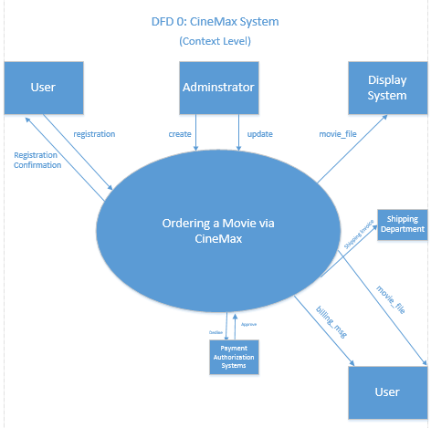

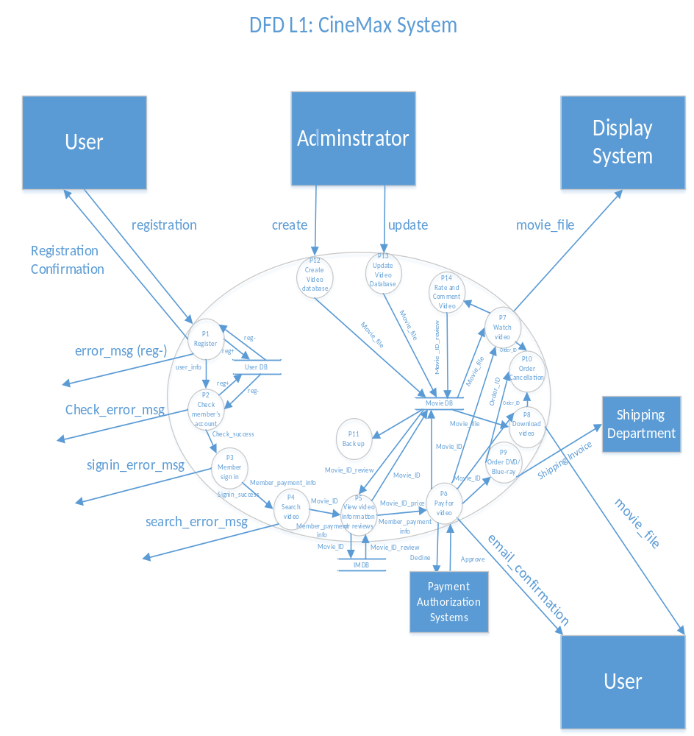

BNF Description of 1 Data Flow

Data Dictionary for CineMax P1 Register

Registration ==> cus_id + password + cus_name + cus_address +cus_phone_no + cus_creditcard + email_address

cus_id ==> 9{n} ⁹
Password=> {a-z+specialchar+n}
cus_name ==> first_name + last_name
cus_address ==> building + street + zip + (country)
cus_phone_no ==> “+1” + ¹⁰{n} ¹⁰
cus_creditcard ==> 16{n} ¹⁶ (For American Express: ¹⁵{n} ¹⁵⁾
email_address ==> 1{a-z} ⁶ + ¹{n} ⁶ + “@” + ¹{a-z} ¹⁰ + “.” + ¹{a-z} ³

